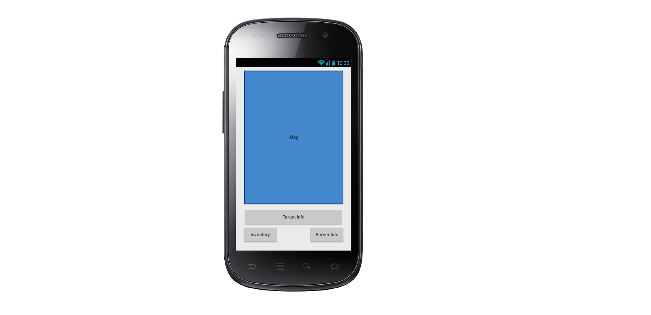The Map screen will serve as the primary interface for the user during gameplay. The map will be drawn from the Google Map API, and will display location details for the user, as well as an active play area, and other users locations when they have been spotted.

Inventory: Opens the players item inventory

Server Info: Opens the game info panel; giving info on other players, play stats, and game setting.

Target Info: Displays your current targets details; physical description, number of kills in current game, and K/D ratio overall.

Map: Displays the users current position, as well as any spotted targets, items, or store locations.

Clicking the map will reveal any targets or items within your spotting range.

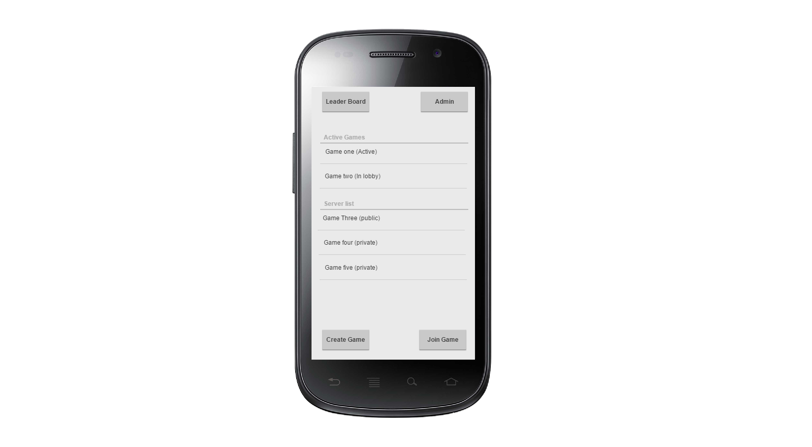Game lobby gives user access to active or available games, as well as an option to create a new game if they are a Host user and access to admin functions if an admin user.

Create Game: Takes user to the create new game menu.

Join Game: Allows user to join the currently selected game from either the active game list, or the Server list.

Server list: Displays a list of visible servers, allowing users to join new games that have not yet started.

Active Games: A list of all games the user is currently involved in; active or waiting in the lobby.

Leader Board: Opens the global Leader board, displaying the ranking of the top players in the game.

Admin: Only visible and enabled for admin level users. Opens the admin consol.